Getting your Global Fishing Watch API Token

This tool pulls its data straight from the Global Fishing Watch (GFW). Before GFW will hand any data over, it needs to know who is asking, and that’s what the API Token is for. It is important that 1 key is used per person, and that this key is kept securely.

- Make a GFW Account
Head to the Registration Page and sign up. If you already have a GFW account, just sign in, and follow step 2.
- Request a Token
Once you’re signed in, go to the Access Tokens page. Under New Token you’ll see two boxes to fill in:
- Application Name – Anything that will help you recognise what it was for
- Description – A short note on what it’s for
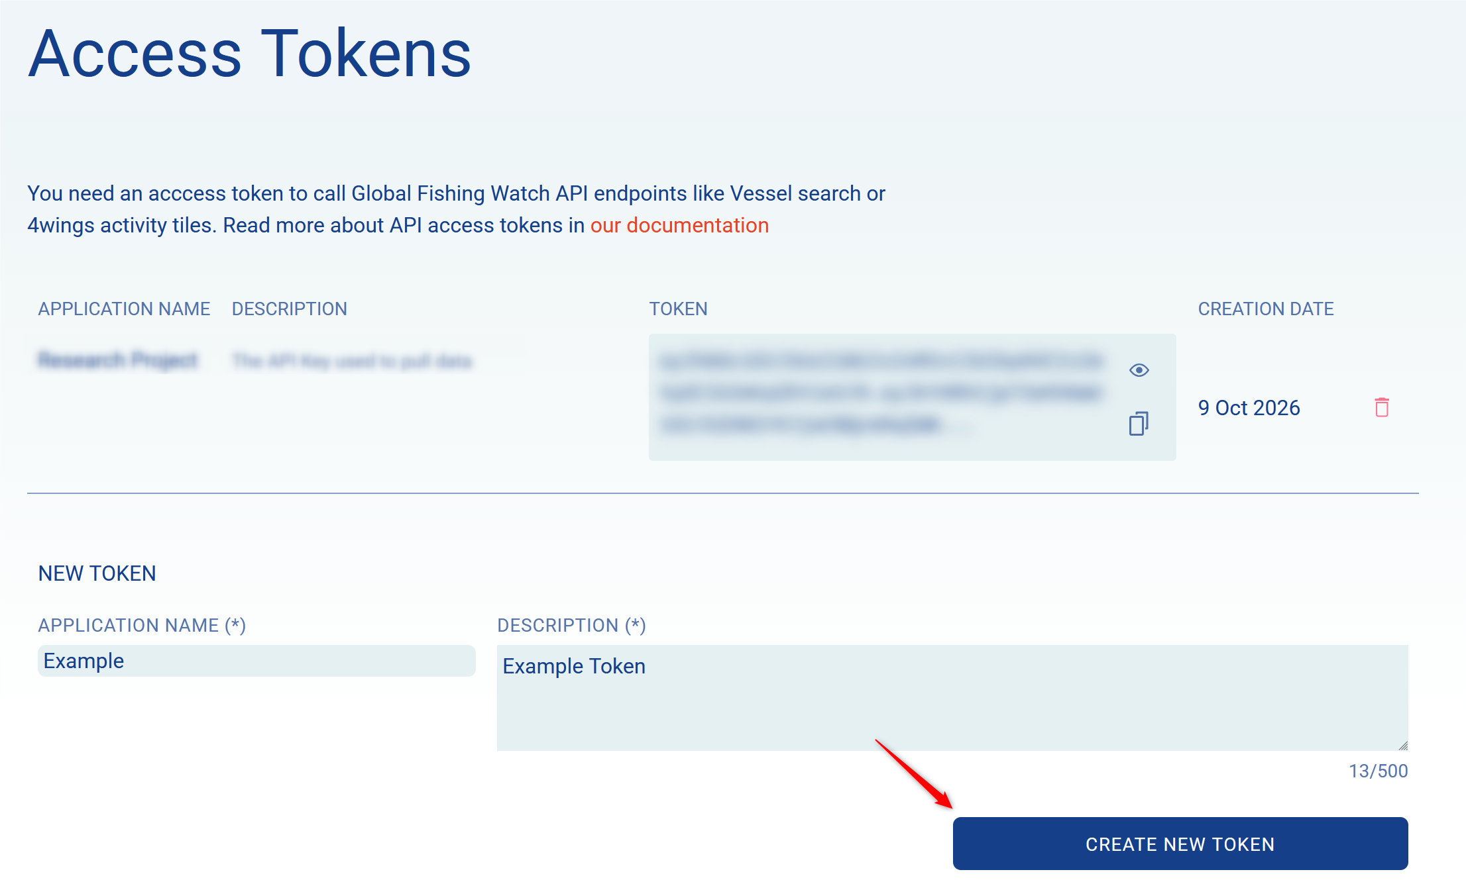
- Copy your Token
Your new Token now shows up in the list. It’s a very long string of letters and numbers, so it’s not worth typing out. Click the copy icon next to it, and it’ll go straight to your clipboard.

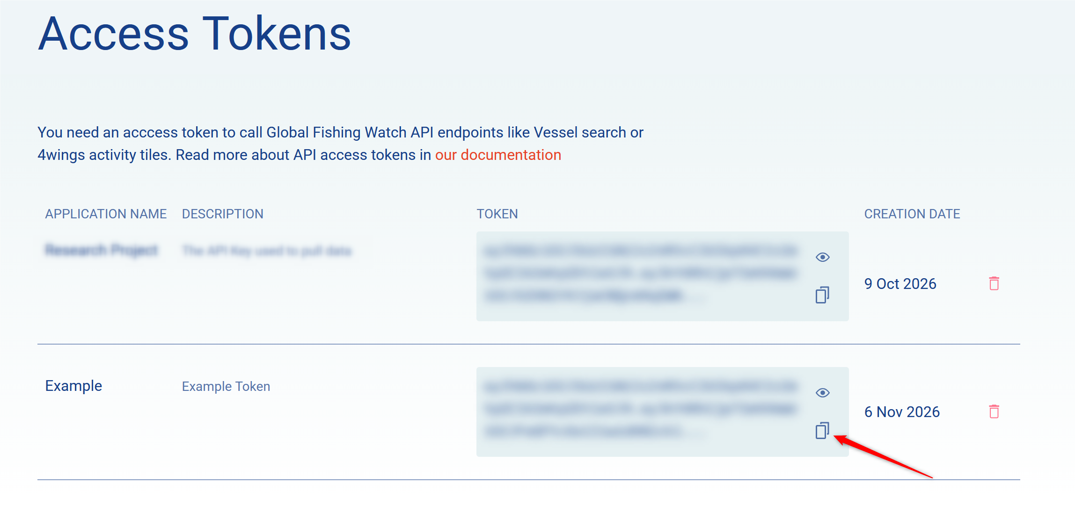
- Add the Token to the tool
In the tool’s project folder, open the .streamlit folder, then open secrets.toml. You’ll see a single line:
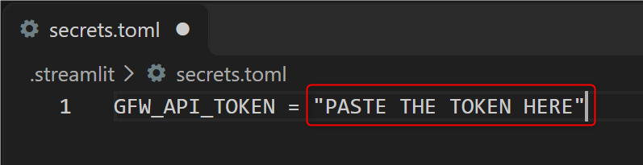
Replace the PASTE TOKEN HERE with your Token, keeping the quotation marks on either side.
Save the file. If the tool is already open, close it and start again, so it picks up the Token

